## Basics

### Open Source

firefox

VLC

GIMP

Blender

Audacity

Wordpress

SHELL

ksh

tsh

tcsh

zsh

Fish

bash

### File Architecture

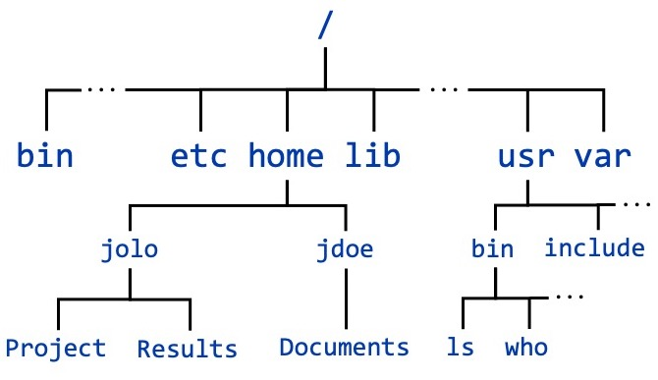

### Command Line Interpreter (CLI)

ls -l

long listing

command options arguments

### ReadLine

### X window system

X11

Wayland

### embedded Linux

glibc

C library

BusyBox

Swiss Army Knife

uCLibc

## Unix Linux BSD

1960s

At&T Bell

Ken Thompson

Dennis Ritchie & Brian kerningham

1970s

BSD (Berkeley)

vi editor

C shell

TCP/IP

1990s

Linus Torvalds

Linux

GPL

1984

Richard Stallman

Free Software foundation

GNU → GNU Not Unix

### glibc

GNU C Library

### Unix based

macOS - Darwin

Solaris

IBM AIX

HPUX

FreeBSD

### Linux based

Debian

MX Linux

Manjaro

Mint

Ubuntu

Kali

Raspbian

BOSS

## Basic commands

### ls

-l long listing

### pwd

### cd

directory_name (cd Desktop)

.. parent

~ home directory

. current directory

### man

1 commands

2 system calls

3 functions

4

7 signals

## Files Directories

relative

cd Desktop

absolute

cd /home/john/Desktop

hidden files/folders:

start with a . <dot>

### commands

cp

mv

rm

rmdir

cd

cat

less

head

tail

nl

### editors

nano

vi (vim)

gedit

atom

sublimetext

vscode

emacs

notepad++

## vi

### insertion mode

i

### command mode

esc

:w save

:wq save & quit

:q! quit without saving

:w! <filename> save as <filename>

yy copy

4yy copy four lines

p pasting

dd cut

deleting

u undo

ctrl + r redo

yiw copy word

### redirection operator

>

>> append

## Users Groups

su switch user

### root

super user → root

privileges:

* full read/write/execute
* creating or installing files or softwares
* modifying files & settings
* creating or deleting users and data

yearly_trainings.data

user: jane

Read r

write w

execute x

user u

group g

other o

chmod o-x

anime.txt

user training others

r w - r w - r - -

1 1 0 1 1 0 1 0 0

6 6 4

r - - r - - r - -

100 100 100

4 4 4

### commands

chmod

only root:-

chown

chgrp

useradd create user

groupadd create a group

passwd update password for a user

usermod modify user’s group or other settings

## intermediate commands

### wc

word count

-w

-c

-l

### find

### pipes

|

### grep

## tar archives

TAR Tape ARchives

gzip

tar.gz

.tgz

bzip

tar.bz2

## links

hard link

symbolic(short) link

inode number

## regex

## Shell Expansions

### wild cards

* 0 or more characters

? 1 character

### tilde expansion

~ home directory

## Process



inode number

### file descriptor

temporary

lowest possible number

0 stdin

1 stdout

2 stderr

pid

tty represents the terminal

### info about process

%CPU

blocked signals

process state

user name (uid)

gid

system time at launch

CPU time

running since

number of threads

pid

ppid

VIRT

%memory

priority

nice

TTY

### commands

#### ps

-a hidden process in the shell

-A al process in the system

aux all process with a different set of columns

-ax all process with a limited set of columns

-ef all process with a different set of columns

-C search a process by name

-o customising (selecting) particular columns

pid

ppid

tty

%cpu

%mem

time

stime

etime

cmd

pri

user

stat

#### fg

#### jobs

#### pidof

#### misc

pkill

killall

skill

pgrep

strep

nice

run a process with specified priority level(niceness)

renice

### background process

&

1. background of the system

daemon

1. background of the terminal

#### jobs

job ids

### threads

part of the process

lwp

## states of a process

R run actively using the CPU

S sleep/wait waiting for an event to happen

waiting for a timer to get over

T stop paused & send to the background

I kernel

## Signals

kill

| signal | keyboard? | can it be ignored? | default action |
| --- | --- | --- | --- |
| SIGTERM | no | yes | terminate the process |
| SIGINT | ctrl + C | yes | terminate the process |
| SIGKILL | no | no | terminate the process |
| SIGSTOP | ctrl + Z | no | stop state |
| SIGCONT | no | yes | continue a process |

SIGTERM 15

SIGINT 2

SIGKILL 9

## network

### MAC address

48 bit

NIC

08:00:32:4d:a11:e8

### IP address

IPv4

32

212.34.40.128

IPv6

128

127.0.0.1

localhost

### DNS

### commands

ifconfig

host

dig

nslookup

ping

packet internet groper

traceroute

### remote connections

File Transfer Protocol (FTP)

Telnet

Secure Shell (SSH)

Remote Desktop Protocol (RDP)

HTTP

### SSH

OpenSSH

ssh remote_host

ssh remote_username@remote_host

client progrm → → sshd

### scp

secure copy

-r recursively copy entire directories

-l limit the bandwidth

## Shell (Bash) Scripting

what is a script

writing a script

#!/bin/bash

run (chmod ) ./

variables & data

### math in shell

let

expr

(( ))

### conditional & flow control

if

## Commands

pwd

ls

cal

bc

date

whatis

man

apropos

clear

mkdir

rmdir

cd

cp

mv

rm

cat

head

tail

less

nl

sudo

who

whoami

su

useradd

groupadd

passwd

usermod

chmod

chown

chgrp

exit